

Sales Order

Standard Operating Procedure

Purpose

This procedure provides the methods for documenting, verifying, and processing sales orders/contracts or requests for SILQ products and that the orders are adequately defined and attainable.

This procedure defines the fulfillment process with the applicable contract manufacturing organization (CMO) for accepted sales orders/contracts from customers and retailers.

Scope

This procedure applies to SILQ personnel and their CMOs involved with aspects of a customer’s order to ensure that they can be met. SILQ departments shall work cross-functionally to ensure that functions within the organization and outside suppliers are aware of customer requirements.

Documents

Reference Documents

QM.SLQ001 Document Control SOP

ISO 13485:2016 International Standards Organization – Medical Devices – Quality Management Systems (section 7.2 – Customer-related processes)

Appendices / Associated Forms / Templates

FM1-QM.SLQ036 Sales Order Form

Definitions

Abbreviations / Acronyms

CMO: Contract Manufacturing Organization

General Definitions

FileHold: Software-based document management system used to electronically store controlled documents.

Sales Order: a document issued by SILQ to a customer or retailer, indicating types, quantities, and agreed prices for SILQ products. It is used to control the purchasing of products from SILQ by the customer or retailer. Issuing an approved sales order to a customer or retailer constitutes a legal contract between SILQ and the customer or retailer for the sale of SILQ products.

Ship Station: Web-based order management and shipping software used to process, fulfill, and ship sales orders to customers.

Responsibilities

Sales/Customer Service (SILQ) – Documents customer orders received by phone, fax, or other means. Initiates sales order by entering data (e.g., customer’s product order, shipping instructions, requested delivery date, etc.) in sales order form.

Chief Commercial Officer (SILQ) – Reviews initiated sales orders and determines if customer requirements and applicable regulatory requirements can be met. If requirements can be met, Operations/Manufacturing approves the sales order. Works with applicable CMO to ensure product is shipped in accordance with the approved sales order. Ensures that traceability of shipped product to consignees and other relevant shipping information is maintained.

Quality Assurance (SILQ) – Closes out sales orders.

Quality management (Contract Manufacturing Organization) –Ensures that picking and shipping of customer inventory per internal procedures. Ensures that traceability of shipped product to consignees and other relevant shipping information is maintained.

Procedure: Completing a Customer Sales Order (Contract)

Initiate Sales Orders (Contracts)

If the customer requests a product that is a SILQ current part number, a Sales/Customer Service associate (or designee) receives the customer’s order from phone, fax, or other means and initiates the sales order.

All sales information is to be documented and maintained. A suggested SILQ Sales Order form is provided in FM1-QM.SLQ036. At a minimum, sales orders are to include the following information:

Customer contact information

Recipient (e.g., Ship To) contact information

Product and quantity requested, including cost

Sales order number

Customer purchase order number, if available

Sales order date (e.g., date when sales order was initiated)

Name of SILQ Sales/Customer Service representative receiving the sales order

Method of shipment

Required delivery date

Any additional requirements specified by the customer, including requirements for delivery and post-delivery activities.

Any product that is not immediately available must be communicated to the customer within 48 hours.

If there are any requirements not stated by the customer but necessary for specified or intended use, a SILQ associate will confirm these requirements with the customer before accepting the order.

Sales/Customer Service representative shall forward the initiated sales order to Operations/Manufacturing management for review and approval.

Sales/Customer Service is to maintain a sales order log (filed in FileHold) which is to include but is not limited to: sales order number, date, customer name and contact information, target delivery date, overall cost information, and actual delivery date.

The Sales Order number schema will be XXXXXXX, a sequential number starting with 0000001. Sales order numbers will unique and not duplicated.

Sales Order/Contract Review and Approval

Operations/Manufacturing management shall review the initiated sales order prior to commitment to supply product to the customer and shall ensure that:

Product requested is approved for commercial distribution in the destination country;

Appropriate language translations for labeling is available for the destination country;

Contract or order requirements differing from those previously expressed are resolved;

Any user training needed to ensure specified performance and safe use of the product is available or planned to be available;

SILQ has the ability to meet the defined customer requirements.

Any failure to meet requirements based on the review shall be addressed and the sales order updated accordingly. The sales order is considered a record of the review and any actions arising from the review.

Once review confirms that all requirements can be met, SILQ Operations/Manufacturing management shall approve the sales order by signing and dating the sales order.

The approved sales order is maintained in FileHold in accordance with Section 7. A copy of the approved sales order is sent to customer.

Fulfillment of an approved sales order shall proceed once a customer purchase order has been issued.

CMO Fulfillment/Shipping of approved sales order

The SILQ Sales/Customer Service associate shall initiate a New Order in Ship Station.

Log into ShipStation account with the following login credentials at https://ship13.shipstation.com/ (See Figure 1 below).

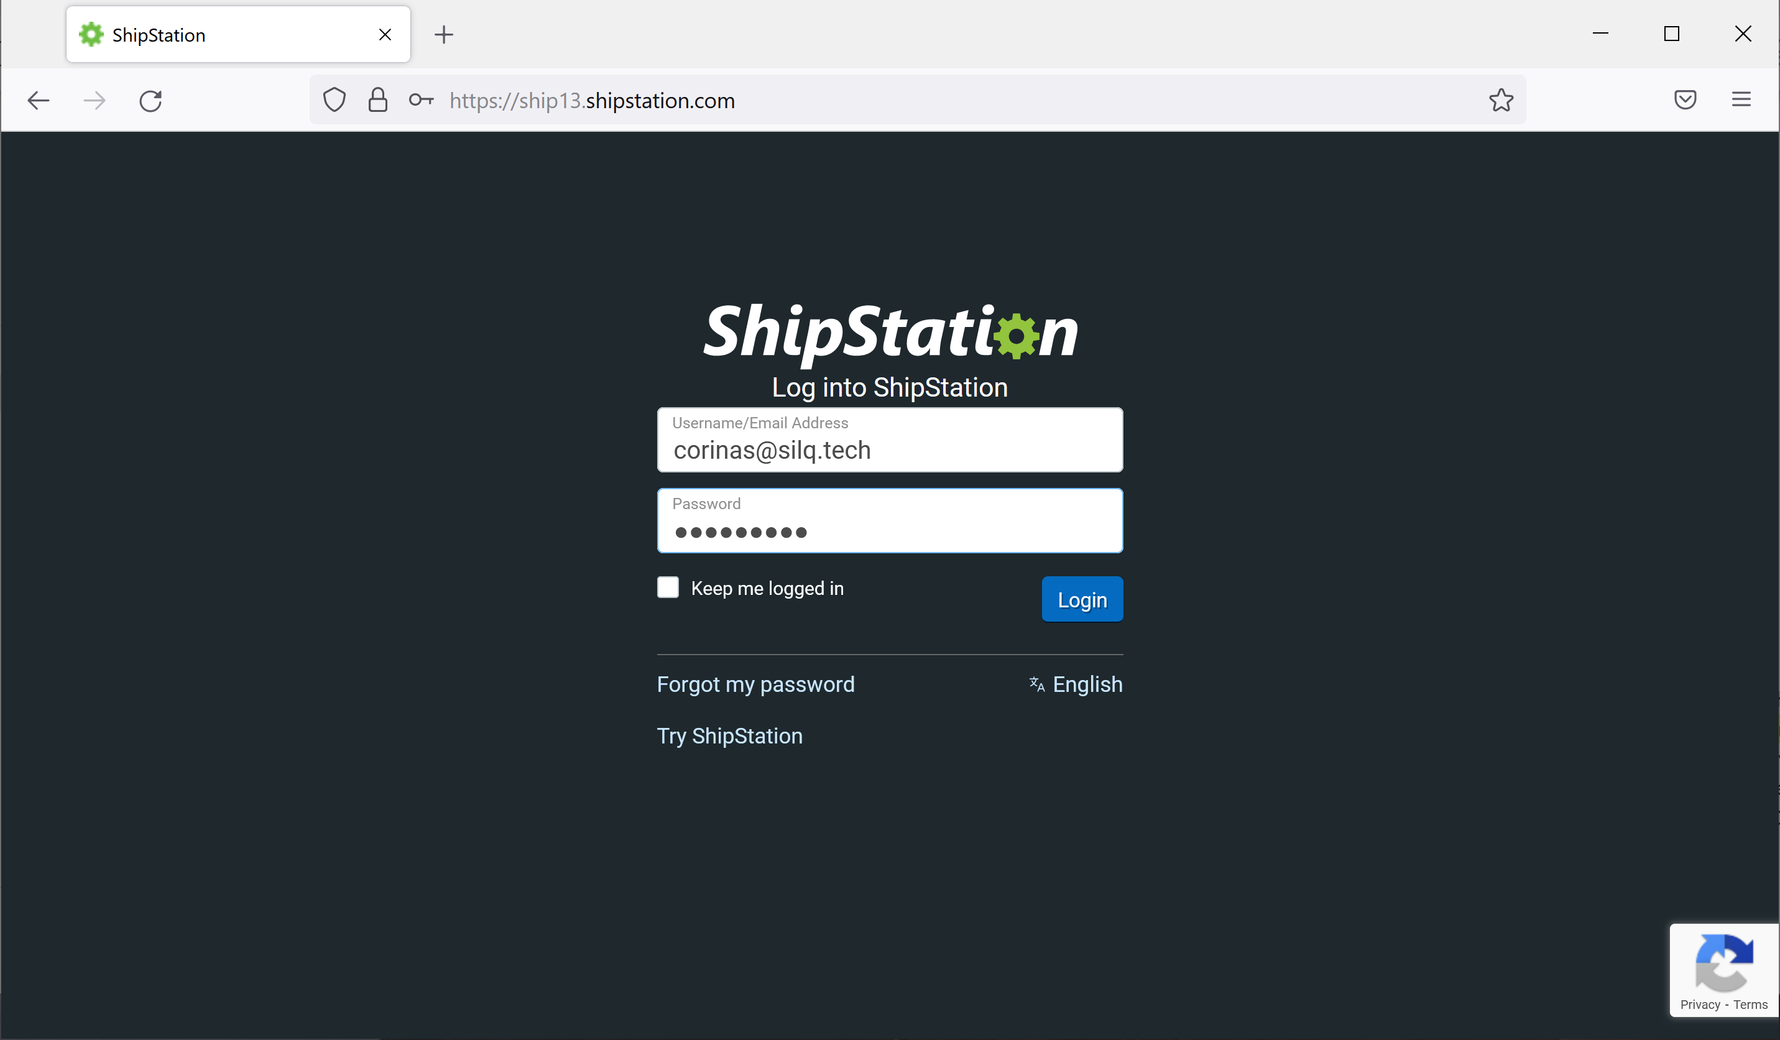
Figure 1. ShipStation login

From the Onboard page, select “Orders” from the drop-down menu (see Figure 2 below).

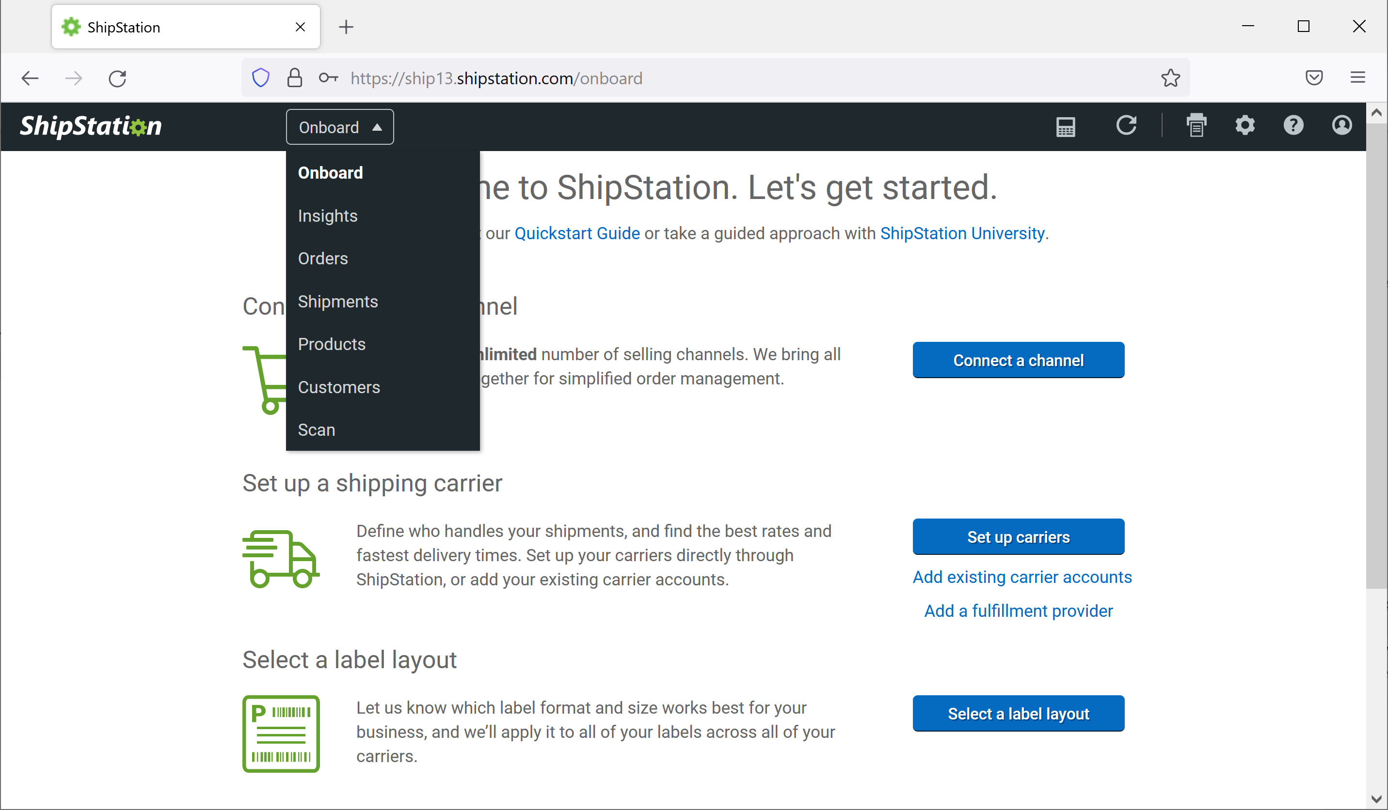
Figure 2. Select “Orders” from drop-down menu on Onboard page

Click on the “New Order” button (see Figure 3 below)

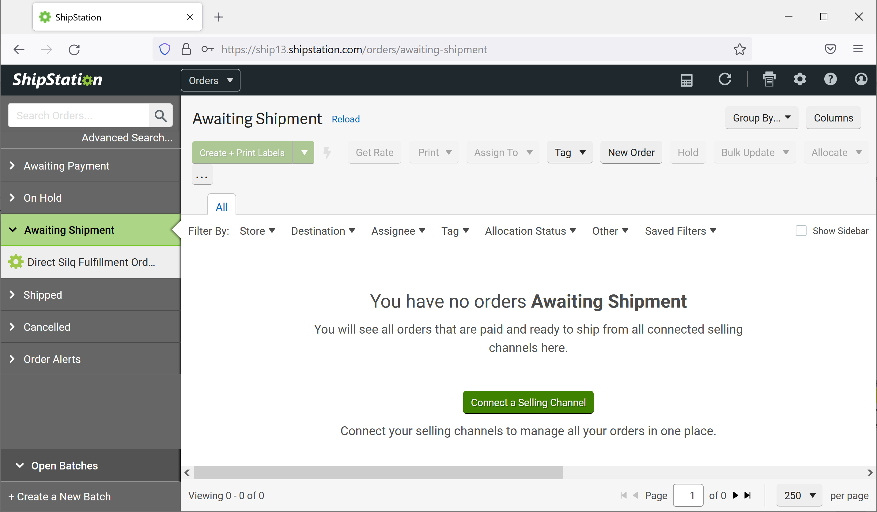
Figure 3. Initiated a new order/shipment fulfillment

Using the information provided on the approved sales order, enter the following information in the New Order window (See Figure 4 below):

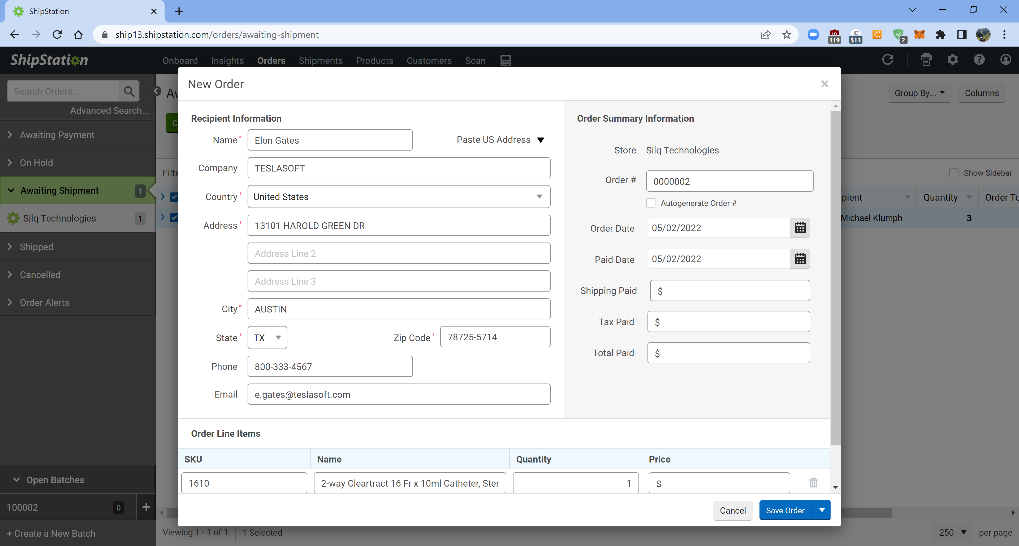
Figure 4. Enter sales order information in the New Order window

Recipient Information

Enter the customer contact name, company, country, address, city, state, zip code, phone, and e-mail address into the appropriate fields.

Order Summary Information

Uncheck the Autogenerate Order # checkbox if it is checked

Order # (e.g., SILQ sales order number)

Order Date (e.g., Sales order date)

Order Line Items

SKU number (e.g., SILQ part number or Pathway part number), product name/description, and quantity.

Click the “Save Order” button. A pop-up window will display the summary of the order.

Expand the Notes section and complete the following (see Figure 5):

Enter the customer purchase order number (if available) in “Note From Buyer” field.

Enter the Target Due Date into the “Custom Field 1” field.

Expand the Configure Shipment section and complete the following (see Figure 5):

Select the shipping method by the Service drop-down list.

Select “Adult Signature Required” from the Confirmation drop-down list.

Select “None” from the Insurance drop-down list.

Verify all information in Order Details window is accurate (see Figure 5 below). Once verified, close Order Details window.

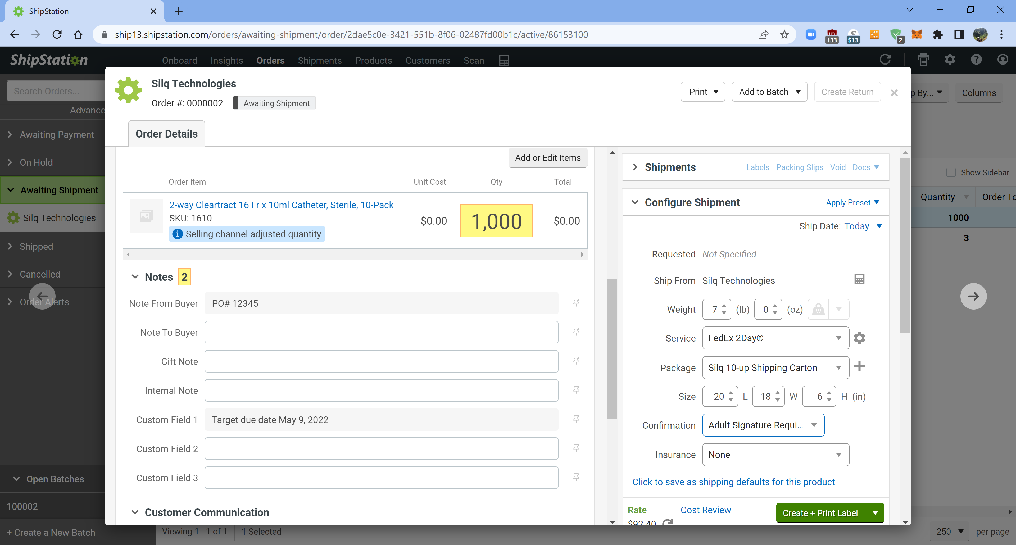
Figure 5. Order Details
Select “Adult Signature Required” for Confirmation
Select shipping method
Select “None” for Insurance
Enter target due date
Enter customer PO #

CMO shall ship product to customer in accordance with the shipping instructions outlined in the order details.

CMO shall maintain traceability of product shipped to consignee which includes, but not limited to, the following information:

Ship date

Consignee name and address

Product and quantity shipped

Product lot number(s)

Delivery method

Actual delivery date

Once product has been delivered to customer, Ship Station will be updated by the CMO to reflect product has been shipped.

CMO will update the Internal Note field in Order Details to add the lot number(s) of product shipped.

Sales Order Closure

For Customer Sales Orders and Retailer stocking orders: Quality Assurance shall obtain a copy of the packing list and attach it to the approved sales order, sign and date the sales order closure section, and update the sales order log with the date of delivery.

For Retailer’s customer order fulfillment: Quality Assurance shall obtain email confirmation from the SILQ Sales/Customer Service associate that sales order was invoiced, sign and date the sales order closure section, update the sales order log date of delivery as “invoiced”.

Amendments to Sales Orders

Any amendments to an approved sales order shall be documented and communicated to the customer. Acceptance of the amendment(s) by SILQ and the customer shall be documented by amending the approved sales order accordingly. The applicable customer purchase order may need to be updated accordingly.

Procedure: Completing a Retailer Sales Order (Contract)

Pre-Order set up

Pathway inventory of FG Catheters for Retailer

Definition: Pathway will physically hold FG Catheters that may be shipped to the Retailer from the same inventory as other FG Catheters are held.

Pathway will continue to provide inventory status of all inventories physically at Pathway to Silq via Ship Station.

Upon Retailer signed agreement, Shipping consigned inventory to Retailer

Retailer notifies Silq of items and quantities to consign

SILQ enters a $0 Sales Order into Sage and load to Ship Station so Pathway can ship items and quantities to Retailer.

SILQ to enter shipment data entry transaction in Sage and invoice $0.

SILQ to enter shipped items and quantities to the Sage Retailer warehouse location.

The SILQ Sales/Customer Service associate shall initiate a New Order in Ship Station and follow the standard operating procedure described in section 6.5.

Silq notification to Pathway to build FG Catheter inventory for potential shipments to Retailer to replenish consigned inventory.

Pathway provides quote to Silq and if OK, Silq provides Pathway a Purchase Order for Pathway to build FG Catheter inventory.

Pathway builds inventory and invoices Silq.

Customer is set up in Sage with billing and shipping information.

Note: Pathway will continue to provide inventory status of all inventories physically at Pathway to Silq via Ship Station.

Order Processing (Retailer sell consigned inventory to customer):

Retailer submits monthly sales tracing report to SILQ with items, number of catheters, zip code and date of sale for each catheter sold to customers.

SILQ enters sales order(s) for Retailer in Sage.

Bill to is Retailer

In sales order, create line items for product sold through and for shipping handling charge amount

SILQ performs shipment data entry transaction (from the Sage Retailer warehouse) in Sage and invoices sales order and remits to Retailer.

Invoice amount is for the agreed upon transfer price from Silq to Retailer and shipping and handling charges.

Retailer submits monthly on hand physical inventory of items and quantities at Retailers warehouse to SILQ.

SILQ reconciles the inventory in Sage in the Retailer warehouse location to the Retailers report.

Once consignment inventory levels decline to the agreed minimum level with Retailer, Retailer notifies SILQ of the need for additional product to again reach agreed consignment level.

Reference section 7.1.2 above to initiate consignment shipping.

Procedure: Sales Order Records Retention

All sales orders and applicable documentation are filed and maintained in the Sales Order drawer of FileHold as a quality record in accordance with record retention policies defined in QM.SLQ001, Document Control SOP.

Records are to be scanned and imported into FileHold and filed within appropriate Sales Order folder.

